Shirtjacke ohne Kapuze  Nr.: 89711 | Farbe/n | S  €32,28 | M  €32,28 | L  €32,28 | XL  €32,28 | 2XL  €35,52 | 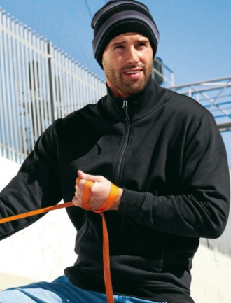  3XL  €35,52

T-Shirt V-Neck  Nr.: 87421 | Farbe/n | M  €13,08 | L  €13,08 | XL  €13,08 | 2XL  €14,40 | 3XL  €14,40 | 4XL  €15,12

